* The Wright brothers invented and flew the 1st airplane in 1903.
* The helicopter was invented in 1940. Although it is slower than airplanes it has the advantage of better control.
* The first manned space mission to moon- Apollo 11, landed on the moon on July 20, 1969.
* After this many space shuttles were sent in space.
* Cars are the most popular means of transport in the world.
* The greatest advancements in cars were made by Henry Ford. 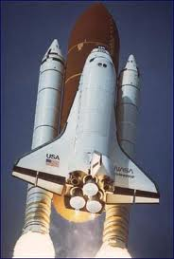
* Cars are powered by liquid fuel-either gasoline or diesel.
* Cars are also very popular in motor sports like f-1 and f-2.

